Salieu, Nick, Saheed, Santiago, Matthew

Group 3 Analysis and Conclusion

Our presentation: The Data Behind the World’s Powerplants, aims to answer the following questions from the energy output of all the powerplants in the world.

1. Top 5 energy producing countries? (All energy sources combined)

The above table shows the data that we were able to find on what are the top 5 countries which produce the most energy. China and the U.S. show up many times throughout our dataset, proving how these two countries dominate the world in energy production. Our findings include data from the following primary fuel types: hydro, solar, wind, oil, gas, wave & tide, cogeneration, petcoke, geothermal, biomass, nuclear, waste, coal, and other types. The standard for energy capacity units is in megawatts (MW) as explained on the right side of the table.

Through further research on the question, China and the U.S. both have the two largest economies in the world. Both are the most industrialized countries in the world, requiring a greater amount of energy produced which help to explain the conclusions of the dataset. The US and Japan are countries classified by the World Bank[1] as high-income countries using the Gross national income  
indicator. Russia and China are upper middle-income economies and India a  
lower middle-income economy and there is no low-income  
country in the top 5 countries.

The total installed capacity for all the countries in the dataset is 5.71 million megawatts and the sum of the top five countries is 3.38 million megawatts, representing 59% of the total installed capacity.

1. What countries have the most installed power generation facilities? (all energy sources combined)

For this question, we looked at the number of power plants each country has then found the top 5 countries with the most installed facilities amongst each primary fuel type (listed in the first question). Once again, the U.S. and China are in the first and second spot. In the first question, we found that China has a slightly higher total energy output than the U.S., but for this question, we were able to determine that the U.S. has a greater number of energy facilities.

Through further research on the question, much of the U.S.’s energy facilities are operated by the private sector, whereas in China, the public sector controls the energy industry. This could help explain why the U.S. has a greater number of installed facilities (competition in the market) whereas China doesn’t.

Two of the other 3 countries are high income countries (United Kingdom and   
France) and an upper middle-income economy, Brazil. The top five installed facilities totaled 21,334 units, representing 61% of the total installed facilities of 31,936 units.

1. For each energy source/type 5 top producing countries?

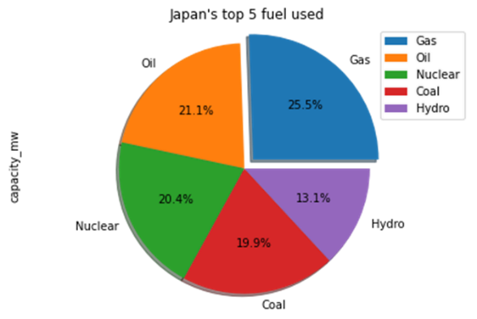

For this question, we aimed to investigate each primary fuel type and see which 5 countries were the top amongst primary fuel type by capacity in megawatts.

We saw 3 of the top five countries in installed capacity (China, United States and India) also leading in solar installation. They are joined by two high income countries (Germany and the United Kingdom). The United Kingdom happens to be among the top 5 countries with the highest installed facilities.   
We also have 3 of the top five countries-installed capacity (China, United States and Russia) leading in hydro capacity. They are joined by Canada and Brazil. Brazil happens to be among the top 5 countries with the highest installed facilities. Wind energy is more generated in high income countries like South Korea, France, United Kingdom and Canada.

A key conclusion to be drawn from this dataset is the role geography plays in certain fuel types. Countries with a lot of open space and strong winds like the U.S. are leaders in wind energy, while countries like Canada with many rivers will have a stronger hydro energy capacity.

1. Top 5 green energy producers

For this question, we looked at what countries had the most installed capacity in green energy in megawatts. This includes hydro, wind, solar, wave & tide, geothermal, biomass, and nuclear energy. We wanted to see the amount of green energy that these countries have relative to their total capacity (as seen in the first question). It is refreshing to know that green energy accounts for a larger portion of countries energy capacity than we initially thought and helps explain how many of these countries aim to move away from a reliance on fossil fuels.

This data is also a shows a stark contrast in which countries are included in the data from the first question. It’s no secret that Russia has a very large energy capacity, however much of that comes from fossil fuels. Brazil is third on our list due to its growing push towards biomass energy. Through further research on the question, we found that biomass energy accounts for roughly 10% of Brazil’s total energy capacity.[2] Canada is number 4 on our list and is a world leader in hydro energy production. Much of this energy comes from Quebec, where the Rupert River allows for ideal conditions for hydro energy production.[3] France is number 5 and is one of the largest producers of nuclear energy in the world. The story with France and nuclear energy is a very interesting one, dating back to 1974 and the OPEC oil embargo. At the time, the price of oil skyrocketed, causing the French government to look for alternative sources of energy.[4] Nuclear energy was chosen as the best alternative and today accounts for roughly 70% of the countries electrical power.

1. What is the relationship between energy production and HDI?

The above data represents a regression analysis we used to see what the relationship looks like between HDI and energy production. We were able to group the countries by region, then look at the summary statistics of each to find the p-value and the correlation coefficient. Through this data, we were able to conclude that there is not a strong correlation between HDI and energy production.

Final Conclusions:

Through our data we were able to work through various conclusions about countries and their sources of energy. China and the U.S. are undeniably the largest energy producers in the world, with other nations such as France, Russia, India, and Japan as having a sizable amount of energy capacity themselves. Through each of the questions, China and the U.S. kept coming up, leading to a more skewed dataset than we initially would have thought.

The dataset did help us come to prior conclusions about countries and their powerplants as highlighted in question 3’s explanation, as well as the role in which income/GDP and geography play in countries’ primary fuel type. As previously mentioned, Canada is a leading hydro power country due to the role their rivers play in their hydro energy output. Geography is not the only source of insight into countries primary fuel, as China and the U.S. have the two largest economies by GDP and produce the most energy in capacity in megawatts amongst multiple fuel types. As mentioned before, other factors are at play in fuel type as in the case of France and nuclear energy. While France is a wealthier nation, their use of nuclear energy is due to economic and geopolitical factors more so than GDP or geography. When it comes to fuel type and countries, there are many factors that contribute to what energy source a country would use.

This project was a very interesting look into many aspects of the world’s energy production. Initially we had no idea about the extent of renewables in the world’s energy output, but it is interesting to see that there is a more sizable role of renewable energy in the world than initially thought.

1. [1] World Bank source (<https://datahelpdesk.worldbank.org/knowledgebase/articles/906519-world-bank-country-and-lending-groups>)
2. “Market overview: Bioenergy in Brazil” 2020. Rodl & Partner.
3. Andrew Finn, “Why Canada is an Energy Titan and it’s Hydropower can Help the U.S.” 2015. Wilson Center.
4. “Nuclear Power in France.” 2022. World Nuclear Association.